

linkedin.com/in/vishal-mahavar-0a49043b3
github.com/vishal-tech3

Table of content:-
- Business Problem ---------------------------------------- 4
- Dataset Information------------------------------------ 5
- Data Cleaning & null handling------------------------7
- Basic Analysis with KPI’s ----------------------------- 10
- Exploratory data analysis------------------------------ 15
- Advance analysis----------------------------------------- 23
- Dashboard & Visualizations-------------------------- 29
7.1 Data insights
7.2 Recommendations
- Skills & tools used ---------------------------------------38
- Outcomes --------------------------------------------------39
- Author details --------------------------------------------40

Project Workflow:

- Business problem
  - Understanding business context
  - problems
- Understanding Data
  - Schema
  - Tables
  - Relations
- Data cleaning:
  - Fixed data types
  - Handled null values
  - Ensured relational and referential integrity
- Data Analysis
  - KPI calculation
  - Trend analysis
  - Customer behavior analysis
  - EDA
  - Product performance
- Dashboard creation (Excel)
  - KPI cards
  - Revenue trends
  - Peak hour analysis
  - Category, size & type wise breakdown

Business Problem:
The objective of this project is to identify key business problems such as The company may lack visibility into revenue trends, underperforming menu items that reduce profitability and lead to insufficient menu management , There may be limited understanding of customer demand patterns including peak ordering hours and days, resulting in missed sales opportunities, additionally unclear insight into customer ordering behavior can hinder effective pricing promotional strategies, The business might also struggle with pricing inefficiencies where higher price items do not generate expected sales and category imbalances , low selling items contribute to inventory waste, data related issues, such as multiple entries or redundancies can create inaccurate KPI calculations and also effects decision making.

Business Context
- The business lacks clarity on revenue drivers
- Customer demand patterns
- Product performance
- Leading to missed growth opportunities.

Objective
- The objective is to identify what drives revenue and where the business is losing potential sales.

#.Dataset Information :
Pizza mania is a database created in mysql in order to solve real world problem related to many fast-food industries which serve pizza as a primary source of revenue and also the industries which serve beverages and fast food.
#1. Schema : pizza_mania
Rows : 48620 Columns : 15 Tables : 4
#2. Tables used in this project:
- Order_details
order_details_id, : unique order id for every row
order_id, : includes multiple orders on same id
pizza_id, : combination of pizza_id and pizza_type_id
quantity : quantity of every order
- Orders
order_id, : includes multiple orders on same id
order_date, : date of every confirmed order
order_time : time of every confirmed order
- Pizzas
pizza_id, : combination of pizza_id and pizza_type_id
pizza_type_id, : combination of pizza name and category
size, : sizes are S, M, L, XL, XXL
price : price of every quantity ordered
- Pizza_types
pizza_type_id, : combination of pizza name and category
name, : name of pizza
category, : category Chicken, Classic, Veggie, Supreme
ingredients : ingredients used in making of pizza
Tables:
Orders
Order_details

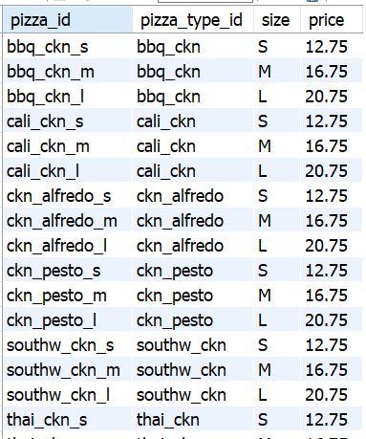
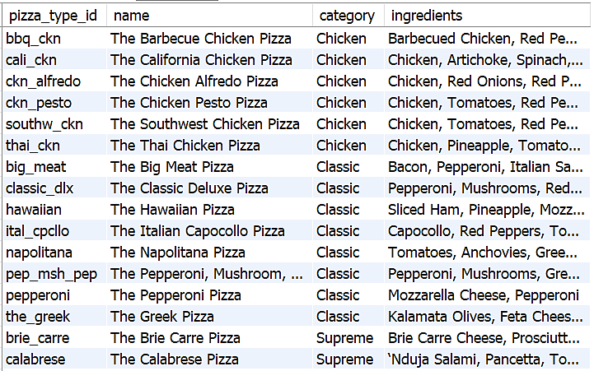
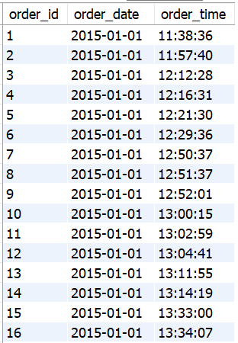
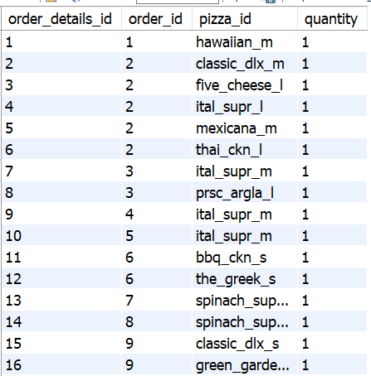
Pizza_types
Pizzas
#. Data Cleaning, null handling & ensured relational integrity:

# Data type correction
SET SQL_SAFE_UPDATES = 0;
ALTER TABLE pizza_types
MODIFY pizza_type_id VARCHAR(50);

ALTER TABLE pizzas
MODIFY pizza_type_id VARCHAR(50);

# Primary key
alter table pizza_types
add primary key (pizza_type_id);

# Foreign key
alter table pizzas
add constraint fk_pizza_type
foreign key (pizza_type_id)
references pizza_types(pizza_type_id);

# Standardize date and time with safe updates off

UPDATE orders
SET order_time = STR_TO_DATE(order_time, '%H:%i:%s');

UPDATE orders
SET order_date = STR_TO_DATE(order_date, '%y-%m-%d');

UPDATE orders
SET order_time = '00:00:00'
WHERE order_time IS NULL;

SET SQL_SAFE_UPDATES = 1;

Null handling & join validation :
# Null checking for every table
SELECT
COUNT(*) AS total_rows,
SUM(CASE WHEN order_details_id IS NULL THEN 1 ELSE 0 END) AS order_id_nulls,
SUM(CASE WHEN order_id IS NULL THEN 1 ELSE 0 END) AS order_id_nulls,
SUM(CASE WHEN pizza_id IS NULL THEN 1 ELSE 0 END) AS pizza_id_nulls,
SUM(CASE WHEN quantity IS NULL THEN 1 ELSE 0 END) AS quantity_nulls
FROM order_details;

SELECT
count(*) as total_rows,
sum(CASE WHEN order_id IS NULL THEN 1 ELSE 0 END) AS order_id_nulls,
sum(CASE WHEN order_id IS NULL THEN 1 ELSE 0 END) AS order_date_nulls,
sum(CASE WHEN order_id IS NULL THEN 1 ELSE 0 END) AS order_time_nulls
FROM orders;

SELECT
count(*) as total_rows,
sum(CASE WHEN pizza_id IS NULL THEN 1 ELSE 0 END) AS pizza_id_nulls,
sum(CASE WHEN pizza_type_id IS NULL THEN 1 ELSE 0 END) AS pizza_type_id_nulls,
sum(CASE WHEN size IS NULL THEN 1 ELSE 0 END) AS size_nulls,
sum(CASE WHEN price IS NULL THEN 1 ELSE 0 END) AS price_nulls
FROM pizzas;

SELECT
count(*) as total_rows,
sum(CASE WHEN pizza_type_id IS NULL THEN 1 ELSE 0 END) AS pizza_type_id_nulls,
sum(CASE WHEN name IS NULL THEN 1 ELSE 0 END) AS pizza_type_id_nulls,
sum(CASE WHEN category IS NULL THEN 1 ELSE 0 END) AS pizza_type_id_nulls,
sum(CASE WHEN ingredients IS NULL THEN 1 ELSE 0 END) AS pizza_type_id_nulls
FROM pizza_types;

# Updating handleable null values
SET SQL_SAFE_UPDATES = 0;

UPDATE pizza_types
SET category = 'others'
WHERE
category IS NULL;

UPDATE pizza_types
SET name = 'unknown'
WHERE
name IS NULL;

UPDATE pizza_types
SET ingredients = 'not available'
WHERE
ingredients IS NULL;
# Deleting non-handleable null values
DELETE FROM orders
WHERE
order_time IS NULL OR
order_date IS NULL OR
order_id IS NULL;

DELETE FROM order_details
WHERE
order_details_id IS NULL
OR order_id IS NULL
OR pizza_id IS NULL
OR quantity IS NULL;

SET SQL_SAFE_UPDATES = 1;

#.Basic Analysis with KPI’s:
SQL Queries

use pizza_mania;
SELECT * FROM orders;
#1. Retrieve the total number of orders placed.

SELECT
COUNT(*) AS total_orders
FROM
orders;

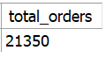
There are total 21350 different orders

#2. Calculate the total revenue generated from pizza sales.

SELECT
SUM(od.quantity * p.price) AS Total_sales
FROM
order_details od
JOIN
pizzas p ON od.pizza_id = p.pizza_id;

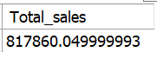
Total revenue generate as on 31-Dec-2015 is $817860.05

#.3 Identify the highest-priced pizza.

SELECT
name, price
FROM
pizza_types pt
JOIN
pizzas p ON pt.pizza_type_id = p.pizza_type_id
ORDER BY price DESC
LIMIT 1;

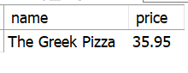
“The Greek Pizza” is the highest price pizza

#.4 Identify the most common pizza size ordered.

SELECT
size, COUNT(DISTINCT order_id) AS total_orders
FROM
order_details od
JOIN
pizzas p ON od.pizza_id = p.pizza_id
GROUP BY size
ORDER BY total_orders DESC
LIMIT 1;

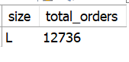
Large pizzas are mostly ordered.
#5. KPI's of orders placed.

SELECT
COUNT(DISTINCT od.order_id) total_orders,
SUM(price * quantity) AS total_revenue,
ROUND(SUM(price * quantity) / COUNT(DISTINCT od.order_id),
2) AS avg_order_value,
SUM(quantity) AS total_pizzas_sold
FROM
orders o
JOIN
order_details od ON o.order_id = od.order_id
JOIN
pizzas p ON od.pizza_id = p.pizza_id;

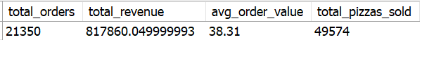
There are total 21350 order placed, 49574 pizzas sold and over 817860 revenue generated over year 2015 with average order value $38.31

#6. Revenue per Pizza

select
round(sum(price*quantity)/ sum(quantity),2) as revenue_per_pizza
from order_details od join pizzas p on od.pizza_id=p.pizza_id;

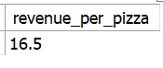
Average revenue generated over pizza quantity is $16.5
#.7 List the top 5 most ordered pizza types along with their quantities.

SELECT
name, SUM(quantity) AS total_qty_ordered
FROM
order_details od
JOIN
pizzas p ON od.pizza_id = p.pizza_id
JOIN
pizza_types pt ON p.pizza_type_id = pt.pizza_type_id
GROUP BY name
ORDER BY total_qty_ordered DESC
LIMIT 5;

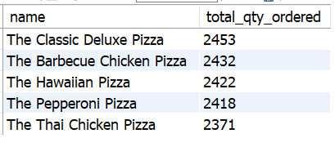
Most ordered pizza quantity is from classic deluxe.

#.8 List the worst 5 ordered pizza types along with their quantities.

SELECT
pt.name,
SUM(od.quantity) AS total_qty
FROM order_details od
JOIN pizzas p ON od.pizza_id = p.pizza_id
JOIN pizza_types pt ON p.pizza_type_id = pt.pizza_type_id
GROUP BY pt.name
ORDER BY total_qty ASC LIMIT 5;

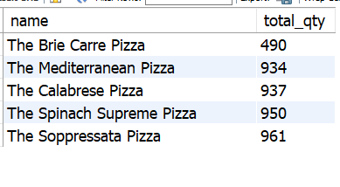
Here are the 5 least ordered pizzas

#.Exploratory Data Analysis:
#.9 Analyze small set of pizzas (~20%) generating (~80%) of the revenue.

with pizza_revenue as (
select
pt.name as pizza_name,
sum(price*quantity) as revenue
from order_details od join pizzas p on od.pizza_id=p.pizza_id join pizza_types pt on p.pizza_type_id= pt.pizza_type_id
group by pt.name
),

ranked as (
select
pizza_name,
revenue,
sum(revenue) over (order by revenue desc) as cumulative_revenue,
sum(revenue) over () as total_revenue
from pizza_revenue
)

select
pizza_name,
revenue,
round(cumulative_revenue*100/total_revenue,2) as cumulative_pct
from ranked
order by revenue desc;

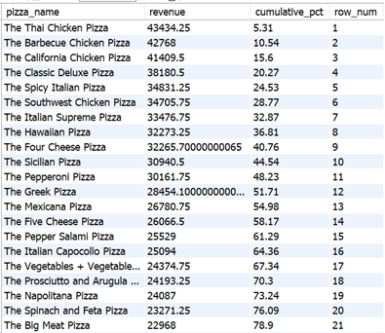
Here are the top (~65%) pizzas generating (~80%) of the total revenue.
#.10 Join relevant tables to find the category-wise distribution of pizzas.

SELECT
category,
COUNT(name) AS total
FROM pizza_types GROUP BY category;
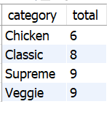
Here are total 27 pizzas over 4 categories
#.11 Join the necessary tables to find the total quantity of each pizza category ordered.

SELECT
category, SUM(quantity) AS total_qty_ordered
FROM
order_details od
JOIN
pizzas p ON od.pizza_id = p.pizza_id
JOIN
pizza_types pt ON p.pizza_type_id = pt.pizza_type_id
GROUP BY category;

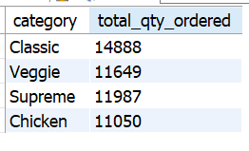
Classic category is the strongest asset, it has the highest brand recognition and customer trust, Veggie and supreme suggest a balance demand, Chicken is trailing
#12. Peak Day Analysis

SELECT
DAYNAME(order_date) AS day_name,
COUNT(DISTINCT order_id) AS total_orders,
concat(round(COUNT(order_id)*100/(select COUNT(DISTINCT order_id) from orders),2),"%") as PCT
FROM orders
GROUP BY day_name
ORDER BY total_orders DESC;

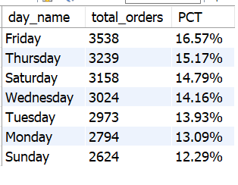
On (Friday, Thursday, Saturday, Wednesday) these day order distribution is 60.69% and 39.31% is for the rest days.

#13. Revenue Growth % (Day-over-Day)
select
order_date,
round(daily_revenue,2) as daily_revenue,
round((daily_revenue - lag(daily_revenue) over (order by order_date))
/ lag(daily_revenue) over(order by order_date)*100,2) as growth_pct
from
(select order_date,
sum(quantity*price) as daily_revenue
from orders o join order_details od on o.order_id=od.order_id
join pizzas p on od.pizza_id=p.pizza_id
group by o.order_date) daily_rev;

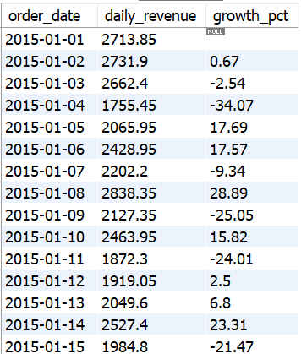

It shows Day-by-day percentage revenue growth

#.14 Determine the distribution of orders by hour of the day.

SELECT
HOUR(order_time) AS Time, COUNT(DISTINCT order_id) AS Total_orders
FROM
orders
GROUP BY HOUR(order_time);

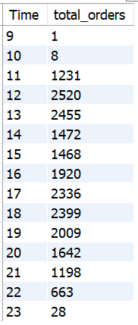

Most orders are seen from 11am to 9pm

#.15 Group the orders by date and calculate the average number of pizzas ordered per day.

SELECT
ROUND(AVG(qty),2) AS avg_order_value
FROM
(SELECT
o.order_date AS date, SUM(od.quantity) AS qty
FROM
order_details od
JOIN orders o ON od.order_id = o.order_id
GROUP BY o.order_date) AS order_qty;
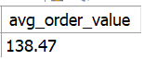
Here is average 138 quantity of pizza ordered pe day

#.16 Determine the top 3 most ordered pizza types based on revenue.

SELECT
pt.name AS Pizza_name,
COUNT(DISTINCT order_id) AS Total_orders,
SUM(quantity) AS Total_quantity_ordered,
CAST(SUM(quantity * price) AS DECIMAL (10 , 2 )) AS revenue
FROM
order_details od
JOIN
pizzas p ON od.pizza_id = p.pizza_id
JOIN
pizza_types pt ON p.pizza_type_id = pt.pizza_type_id
GROUP BY pt.name
ORDER BY revenue DESC
LIMIT 3;

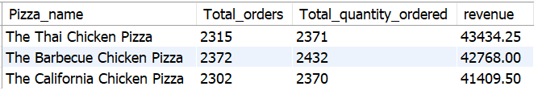
most revenue of orders are form these 3 pizza categories

#. Advanced Analysis:
#.17 Calculate the percentage contribution of each pizza type to total revenue.

with cte (name,revenue) as(
select
pt.category as name,
cast(sum(quantity*price) as decimal (10,2)) as revenue
from order_details od
join pizzas p on od.pizza_id=p.pizza_id
join pizza_types pt
on p.pizza_type_id= pt.pizza_type_id
group by pt.category
)

select
name,
revenue*100/(select cast(sum(quantity*price) as decimal (10,2)) as revenue
from
order_details od join pizzas p
on od.pizza_id=p.pizza_id
join pizza_types pt
on p.pizza_type_id= pt.pizza_type_id) as PCT
from cte
order by revenue desc;
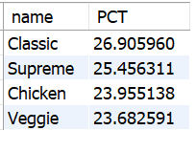
Classic share most of the revenue distribution while veggie is the least of it.

#.18 Contribution % of Each Pizza

SELECT
pt.name,
ROUND(SUM(od.quantity * p.price) * 100 /
(SELECT SUM(od2.quantity * p2.price)
FROM order_details od2
JOIN pizzas p2 ON od2.pizza_id = p2.pizza_id), 2) AS contribution_pct
FROM order_details od
JOIN pizzas p ON od.pizza_id = p.pizza_id
JOIN pizza_types pt ON p.pizza_type_id = pt.pizza_type_id
GROUP BY pt.name
ORDER BY contribution_pct DESC;
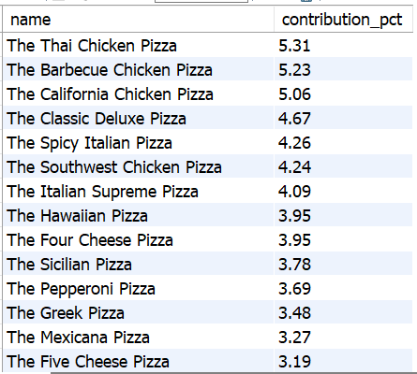

Here is percentage wise distribution of pizzas over revenue

#.19 Size-wise Revenue Share

with rev as (
select
size,
sum(price*quantity) as revenue
from order_details od join pizzas p on od.pizza_id=p.pizza_id group by size
)

select
size,
revenue*100/(select sum(price*quantity) from order_details od join pizzas p on od.pizza_id=p.pizza_id) as PCT from rev;

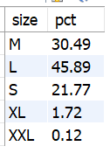
Here is percentage wise distribution of revenue share of Large size is the most while XXL and XL are the least

#.20 Peak vs Non-Peak Revenue

with rev as (
select
sum(price*quantity) as revenue
from order_details od join pizzas p on od.pizza_id=p.pizza_id
)

select
case
when hour(order_time) between 12 and 15 then "Lunch"
when hour(order_time) between 18 and 22 then "Dinner"
else "Off-peak"
end as Time_slot,
sum(price*quantity) as revenue,
round(sum(price*quantity)*100/(select revenue from rev),2) as PCT
from orders o
JOIN order_details od ON o.order_id = od.order_id
JOIN pizzas p ON od.pizza_id = p.pizza_id
group by time_slot;

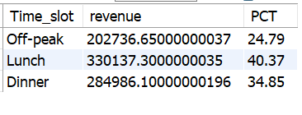
Revenue distributed over Peak vs Non-peak hours, during ‘Lunch’ peak hours revenue distribution is the most 40.37% and followed by Dinner peak hour with 34.85% then Off-peak hours which is the lowest 24.79%

#.21 Determine the top 3 most ordered pizza types based on revenue for each pizza category.

SELECT
CATEGORY,
NAME,
revenue
FROM
(SELECT
category,
NAME,
total_orders,
revenue,
rank() OVER(PARTITION BY category ORDER BY revenue DESC) AS rnk
FROM
(SELECT
pt.category,
pt.name,
COUNT(DISTINCT order_id) total_orders, CAST(SUM(quantity*price) AS DECIMAL (10,2)) AS revenue
FROM
order_details od JOIN pizzas p
ON od.pizza_id=p.pizza_id
JOIN pizza_types pt
ON p.pizza_type_id= pt.pizza_type_id
GROUP BY pt.category,pt.name) AS cat_total) AS cat_rank

WHERE rnk <=3;
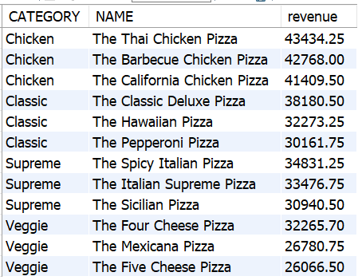
Here are the top 3 sales of each pizza category which shares approx 50% of the sales
#.Dashboard & Visualizations:
Key progression indications-
Key Progression Indications of 2015 sales summary:
There is 21350 different orders ordered in 2015 with Total revenue generated $817860.05, Average order value (total revenue*100/total different orders) was $38.30, Total 49574 quantity of pizzas sold, Average Revenue of each pizza (total revenue*100/total quantity) was $16.50.
$ 817860.05
$ 38.3072623
$16.49776193
21350
49574
Total revenue
Average order value
Total orders
Total pizzas sold
Revenue per pizza

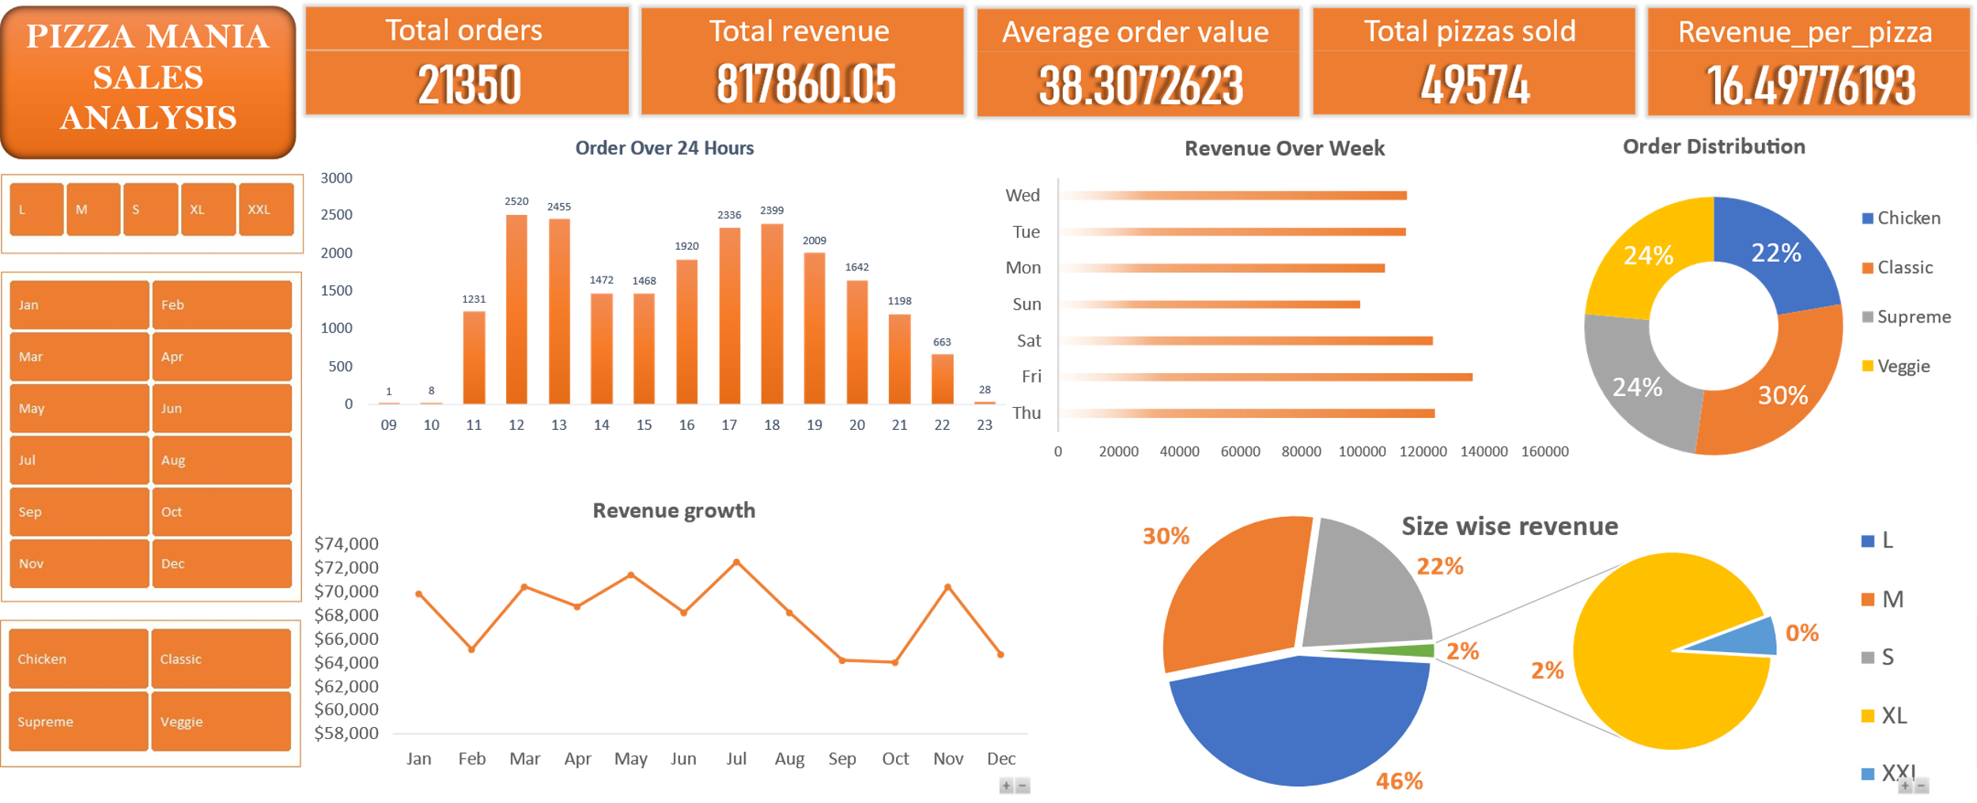
Dashboard:
“Pizza Mania’s revenue is primarily driven by peak-hour demand, large-size pizzas, and a small group of top-performing products, while off-peak hours and underperforming categories represent key growth opportunities.”

- Key Insights:
  - Most orders are concentrated between 11am to 9pm with clear peak during
  - Lunch (12pm – 1pm)
  - Evening (4pm – 7pm)
  - Off peak hours shows a sharp decline in orders after 10 pm and before 11am and mid between 2 & 3pm
- Recommendation:
  - Ensure strongest and most experienced staff is on ground during peak hours.
  - Volume drop sharply after 10pm analyze the labor cost versus the revenue of the 28 orders placed at 11 to see if closing an hour earlier is a more profitable move
  - The lunch peak is a sharper and more condensed than evening ensure ingredients and raw materials are available at these hours so the kitchen ensure smooth operation when rush doubles at noon.

- Key Insights:
- Revenue trend shows inconsistent demand over months.
- Peak performance is observed in march may July and November .
- Significant dips are observed in fab august - oct.

- Recommendation:
- Low performing months
- Introduce Seasonal promotions and discount.
- launch happy hours and bundle deals in slow periods and limited time offer to create urgency, reduce waste during low months.
- High performing months
- focus on top selling items, remove and redesign for low performing items
- avoid stockouts in July or Nov.

Key Insights:
- Classic pizza dominated with (~30%) of total orders making them the most preferred category.
- Supreme and veggie contributes equally (~24%) indicate stable mid-level demand.
- Chicken category underperforming.
Recommendation:
- High demand
- Promote classic pizzas as flagship products in marketing campaigns.
- Introduce premium variants or upper size combos to increase revenue from high demand
- Low demand
- Reposition chicken pizza with new flavors, offers or combos
- Offer 15% discount on chicken category.
- Run targeted discount or bundle deals to improve sales share
- Stable demand
  - Maintain consistent quality & availability.
  - Veggie likely attracts a specific audience segment
  - Target veggie and supreme segmentation with personalized offers
  - Use ordering patterns to create customized recommendations.
  - Focus on marketing of veggie and supreme category in order to improve overall profit margins

Key Insights:
- Highest demand - Friday, Saturday & thursday
- Lowest demand – Sunday & monday
- Monday-Wednesday are moderate but stable demand.
Recommendation:
- High performing days
- focus on top selling items, remove and redesign for low performing items
- avoid stockouts in Tuesday - Saturday
- align staff shifts and inventory planning to perform smooth operation
- premium combos and upscaling strategies to capitalize on high demand
- Low performing days
- Launch & promotes ads before these days
- Launch offers on these days
- Launch Discount package on these days

- Key Insights
  - Large pizza dominates revenue (~46%) making them primary source of revenue
  - Medium contributes (~30%) secondary demand
  - Small contributes weak demand
  - XL and XXL contributes the least suggesting weakes demand

- Recommendation:
  - Promote large pizza as best value option
  - Large pizza dominates the most, shows demand for regular customer, bundle with drinks/beverages to increase average order value
  - Highlight (L) & (M) visually, most popular tag generates most of the revenue
  - Reprice and bundling small size as a personal meal deal
  - For XXL and XL target occasion, sport event or gathering

Problem Areas
- Off peak hours indicating low utilization of materials it affecting the proper utilization of staff(manpower) and resources fuels(electricity etc.)
- Chicken category shows weak performance compare to others
- Small Extra-large and Excess-extra-large contributing least indicates that number of orders and revenue share both are affecting
- During low demand days capacity isn’t sufficiently using it leads of waste of materials

Business Recommendations:
- Revenue optimization
- Focus on top-performing pizzas (high contribution group)
- Introduce premium pricing for high-demand items
- Menu engineering
  - Redesign or remove bottom 20% low-performing pizzas
  - Reposition chicken category using combos or discounts
- Demand optimization
  - Lunch off-peak promotions (2-5 PM)
  - Introduce “Happy Hour” pricing to improve utilization
- Operational efficiency
  - Align staffing with peak hours
  - Reduce operational cost during low-demand hours
- Upselling strategy
  - Bundle large pizzas + beverages
  - Promote “Most popular” items visually in menu


Tools & skills used :
- SQL: (MySQL) Workbench is 8.0.44 (released October 6, 2025)

Data Cleaning & Analysis
- MS-Office 2021: Word, Excel

Dashboard & Visualization
- Data Analysis: Trend analysis, business insights, recommendations

Outcomes:

“ This Project which is my very first complete project helped me to understand the data, how to clean analyses manipulate and explore the data and then turn that data into visuals in order to extract actionable insights and use the insights to give data-driven recommendations.”

Author :-
Vishal
[LinkedIn] https://www.linkedin.com/in/vishal-mahavar-0a49043b3
[GitHub] https://github.com/vishal-tech3

